TASK 6 – Inheritance and Constructor Chaining

Aim
To implement inheritance in the Campus Smart-Parking System using a Vehicle superclass and the subclasses TwoWheeler, Car, and ElectricCar.

1. Inheritance Hierarchy
Vehicle
/ \
TwoWheeler Car
|
ElectricCar
- Vehicle: Base class containing common vehicle details.
- TwoWheeler: Represents two-wheeled vehicles.
- Car: Represents cars.
- ElectricCar: Represents electric cars and inherits the properties of Car.

2. Java Program
class Vehicle {
String vehicleNo;
Vehicle(String vehicleNo) {
this.vehicleNo = vehicleNo;
System.out.println("Vehicle Constructor");
}
void display() {
System.out.println("Vehicle No: " + vehicleNo);
}
}
class TwoWheeler extends Vehicle {
TwoWheeler(String vehicleNo) {
super(vehicleNo);
System.out.println("TwoWheeler Constructor");
}
}
class Car extends Vehicle {
Car(String vehicleNo) {
super(vehicleNo);
System.out.println("Car Constructor");
}
}
class ElectricCar extends Car {
ElectricCar(String vehicleNo) {
super(vehicleNo);
System.out.println("ElectricCar Constructor");
}
}
public class Main {
public static void main(String[] args) {
ElectricCar e = new ElectricCar("TN01AB1234");
e.display();
}
}
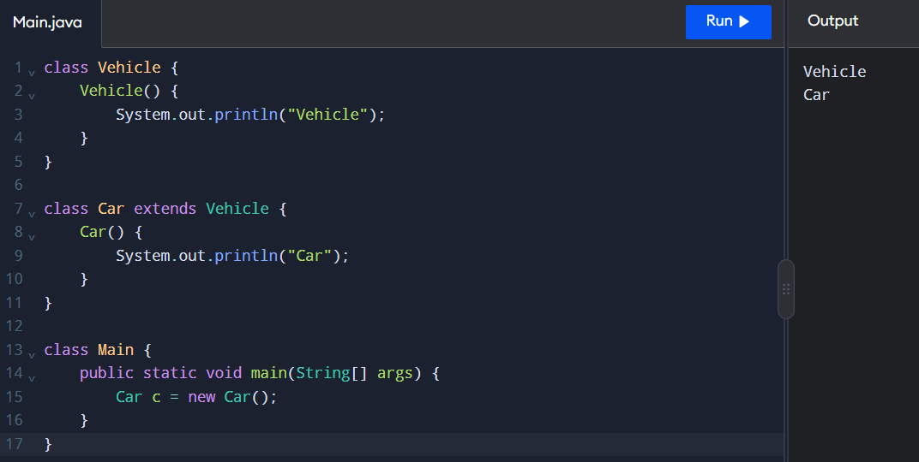

3. Expected Output
Vehicle Constructor
Car Constructor
ElectricCar Constructor
Vehicle No: TN01AB1234

4. Explanation of super Keyword
- super() calls the constructor of the parent class.
- In Car, super(vehicleNo) calls the Vehicle constructor.
- In ElectricCar, super(vehicleNo) calls the Car constructor.
- Parent constructors execute before child constructors.
- In Java, a call to super() must be the first statement in the constructor when explicitly used.

5. Constructor Execution Trace
When the statement new ElectricCar("TN01AB1234") executes:
- The ElectricCar constructor starts.
- It calls the Car constructor using super(vehicleNo).
- The Car constructor calls the Vehicle constructor.
- The Vehicle constructor initializes vehicleNo.
- The constructors complete in order: Vehicle, Car, and ElectricCar.
- The vehicle number is displayed.

6. Inheritance vs Composition
Inheritance | Composition
Represents an is-a relationship. | Represents a has-a relationship.
Uses extends in Java. | Uses an object as a member of another class.
Shares and extends parent-class features. | Combines separate objects to provide functionality.
Example: ElectricCar is a Car. | Example: ParkingFacility has ParkingSlot objects.
Useful for related vehicle types. | Useful for flexible system design.

Result
Inheritance was implemented successfully using the Vehicle, TwoWheeler, Car, and ElectricCar classes. The super keyword demonstrated constructor chaining, and the output confirmed the order of constructor execution.

